

UNDERGRADUATE PROJECT PROPOSAL

|  |  |
| --- | --- |
| **Project Title:** | **Inception-Enhanced Depthwise CNN of Residual Learning for Breast Cancer Diagnosis** |
| **Surname:** | **Wu** |
| **First Name:** | **Keliang** |
| **Student Number:** | **202018010212** |
| **Supervisor Name:** | **Dr Grace Ugochi Nneji** |
| **Module Code:** | **CHC 6096** |
| **Module Name:** | **Project** |
| **Date Submitted:** | **2023/11/03** |

**Table of Contents**

1 Introduction 2

1.1 Background 2

1.2 Aim 2

1.3 Objectives 3

1.4 Project Overview 3

1.4.1 Scope 3

1.4.2 Audience 4

2 Background Review 6

3 Methodology 8

3.1 Approach 8

3.1.1 Inception Network Version 4 (V4) 8

3.1.2 Residual Network 8

3.1.3 Inception-ResNet Block 9

3.1.4 Depthwise Convolution Model 10

3.1.5 Depthwise-Inception-ResNet Model 11

3.2Technology..............................................................................................................12

3.3 Version management plan 12

4 Project Management 13

4.1 Activities 13

4.2 Schedule 14

4.3 Data management plan 14

4.4 Deliverables 14

5 References‌‌‌‌‌‌‌‌‌‌‌‌‌‌‌‌‌‌‌‌‌‌‌...............................................................................................................................16

# **Introduction**

## **Background**

Breast cancer is the one of the most fatal diseases so far in the world. It is said by American cancer society surveillance that one out of eight women is affected by it [1]. According to statistics recorded by World Health Organization (WHO) [2] among the 9.6 million cancer-related deaths, 627,000 females passed away due to breast cancer in 2018, in addition, WHO had also predicted that 43,600 women would die from breast cancer in 2021 [3], which indicates that breast cancer remains the leading cause of women death.

Breast cancer is similar to other type of cancer which can be early stage (Benign) and later stage (Malignant). Once the disease reached malignant stage, cancer might spread to other parts of the body which leads to catastrophic results, therefore, it is crucial to detect breast cancer at early stage in order to provide appropriate treatment [4]. Mammography serves as a common approach for breast cancer detection which the picture is normally taken through Magnetic Resonance Imaging (MRI), X-Ray, and Ultrasound, other methods rely on tissue sample from affected area of breasts and complete the diagnosis and classify by microscope [5].

It is unfortunate that the diagnosis still face troubles. Manual diagnosis through medical images or microscope is time-intensive, expensive and prone to errors, as symptoms are likely to be overseen [6]. For example, ultrasound breast cancer images detection highly depends on the experience, capability and knowledge of radiologists and diagnosticians [7], which most of the small hospital might not be equipped with.

Therefore, development and deployment of a deep learning based system focused on classification and diagnosis of breast cancer is the main goal of this project so as to avoid man power wastes, applying more targeted treatment to patients, lowering death rate, save more lives.

## **Aim**

Various models in deep learning diagnosis utilize specific single model, however, by doing so, there are chances that flaws of specific models could affect the performance in a negative way. To eliminate the drawbacks and maximize the performance, this project aims at develop and deploy a novel CNN model including Inception-ResNet model to classify the levels of breast cancer. Based on Wang et al. [8], Inception-ResNet possess a remarkable balance between model accuracy and resource efficiency.

## **Objectives**

The project will collect breast cancer symptom data from online sources, utilizing datasets like BreakHis, IDC, and mini-DDSM. BreakHis has benign and malignant categories with 9,109 microscope images from 82 patients. IDC contains 198,738 negative and 78,786 positive invasive carcinoma images. The data will be divided into training and testing sets for four different scaled images, with an 80% portion allocated for training and a 20% portion for testing. Within the training set, 10% of the images will be randomly selected as a validation set. It is essential to include both benign and malignant samples in both sets.

The project aims to build a Depthwise-Inception-ResNet-Attention model, with hyperparameter adjustments: batch size of 4, learning rate at 0.001, dropout between 0.3 to 0.5. For binary classification, the output layer will use "sigmoid" activation, "Adam" optimizer, and "Binary-Crossentropy" loss function.

In addition, the evaluation of the model will include metrics such as "Accuracy" and "Loss." Moreover, performance will be assessed using "Precision," "Recall," "F1-Score," "AUC-ROC," "AUC-PR," "Specificity," "Sensitivity," and the "Confusion Matrix.

Lastly, the project will be deployed through a website which allows uploading medical pictures of breast cancer, then give the classification results.

## **Project Overview**

### **Scope**

Convolutional Neural Networks (CNNs) were introduced to medical image processing in the 1980s and have become the dominant approach in this field [9]-[10]. While Inception-ResNet delivers impressive performance, models not tailored to specific scenarios often encounter issues like gradient vanishing, local minima, and overfitting. Therefore, enhancing Inception-ResNet through the incorporation of depthwise operations is imperative. By using depthwise operations, it will reduce the parameter count, thus, improving the network's efficiency and effectiveness, all the while conserving computational resources by eliminating unnecessary parameters [11].

The following are the significances of this project and potential contributions:

* Enhanced Breast Cancer Diagnosis Accessibility
* Improved Diagnosis Efficiency
* Reduced Misdiagnosis Rate
* Early detection and Prevention
* Conserved Medical Resources and Improved Allocation
* Increased Life Saving Rate
* Cost-Effective Healthcare Solutions
* Promotion of Public Health Awareness

### **Audience**

The development of a specialized system for breast cancer diagnosis will bring about significant benefits to various stakeholders.

* **Medical Professionals:** Radiologists and oncologists will benefit from the enhanced accuracy and efficiency of breast cancer diagnosis. The CNN can aid in early detection, reducing the chances of misdiagnosis and allowing for more timely interventions.
* **Hospitals and Clinics:** Healthcare institutions will experience improved workflow and reduced diagnostic errors, which can lead to better patient care and outcomes. It can also streamline the diagnostic process, potentially reducing the burden on healthcare resources.
* **Breast Cancer Patients:** Patients will benefit from faster and more accurate diagnosis, resulting in quicker treatment initiation and improved chances of survival. Additionally, reduced false positives and negatives can alleviate the emotional stress associated with diagnostic uncertainty.
* **Medical Researchers:** Researchers can access a valuable tool for analyzing a vast amount of medical imaging data, facilitating advancements in breast cancer research and treatment methods.

In summary, the proposed depthwise-Inception-ResNet model promises benefits for medical professionals, healthcare institutions, breast cancer patients, and the broader research community by enhancing the accuracy, efficiency, and overall quality of breast cancer diagnosis and care.

# **Background Review**

Various methods had enhanced breast cancer classification. This section will present works that had been done for breast cancer classification.

Hirra et al. [1] proposed Pa-DBN-BC, a patch-based deep learning method, achieving 86% accuracy in diagnosing cancer from histopathology images. Sahu et al. [6] introduced a model trained on mini-DDSM, yielding 99.17% and 97.75% accuracy for abnormalities and malignancy. Liang and Meng [9] achieved high accuracy in binary and eight-class classification with BreakHis datasets. Alkhaldi et al. [11] utilized ensemble optimization, attaining 92.874% accuracy in Invasive Ductal Carcinoma classification.

Xu et al. [13] introduced an attention mechanism network with 98% accuracy, albeit limited by the smaller BreakHis dataset. Wu et al. [14] trained on 224,426 mammography images, reaching an AUC of 0.895. Chougrad et al. [15] employed transfer learning, achieving 98.94% accuracy post-merging datasets. Yu et al. [16] used SCDA data augmentation with ResNet-50, obtaining 95.74% accuracy, 98.55% specificity, and 92.83% sensitivity. Arya and Saha [17] developed a stacked-based ensemble model with 90.2% accuracy for breast cancer prognosis. Whitney et al. [10] highlighted the efficacy of CNN transfer learning in diverse imaging modalities for accurate breast cancer diagnosis.

A summary of the different researchers and their findings and possible results can be found in Table 1

|  |  |  |  |
| --- | --- | --- | --- |
| Author | Datasets | Methods & Models | Results |
| Hirra et al. [1] | Histopathology images | Patch-based deep learning & Deep belief Network | 86% |
| Sahu et al. [6] | Mini-DDSM &  Ultrasound  images(BUSI) | AlexNet+ResNet+MobileNeetV2 | Abnormalities: 99.17% and 97.75% mini-DDSM and BUSI  Malignancy: 96.92% and 94.62% mini-DDSM and ultrasound |
| Liang and Meng [9] | BreakHis | Convolutional Block Attention Module and Convolutional Multi-Layer Perceptron | 95.5% |
| Alkhaldi et al. [12] | Invasive-Ductal-Carcinoma (IDC) | Multi-ResNet CNN | 92.874% |
| Xu et al. [13] | BreakHis | DeNet | 98% |
| Wu et al. [14] | 224,426 mammography | Ensemble of Four ResNets | 0.895 in AUC |
| Chougrad et al. [15] | INbreast, DDSM, BCDR | VGG16, ResNet50, IncetpionV3 | DDSM: 97% accuracy, 0.98 on AUC;  INbreast: 95.5% accuracy, 0.97 on AUC  BCDR: 96.67% accuracy, 0.96 on AUC  Independent database (MIAS): 98.23% accuracy, 0.99 on AUC |
| Yu et al. [16] | INbreast, mini-DDSM | SCDA augmentation  & ResNet-50 | 95.74% accuracy, 98.55 specificity, 92.83% sensitivity |
| Arya and Saha [17] | 1,980 patients’ breast cancer data | stacked ensemble model | AUC of 0.93 and 90.2% accuracy |

Table 1: Summary of Related Works

# **Methodology**

## **Approach**

The proposed CNN model comprises two individual models with two mechanisms. The basic idea is to combine Inception-V4 Model, Residual Network, and integrate attention mechanism and depthwise convolution which are respectively used to concentrate on relevant features and to reduce the computation resources.

### **Inception Network Version 4 (V4)**

Inception V4, as shown in figure 1, introduced by Google researchers in 2016, is a deep learning architecture renowned for its advanced techniques, including inception modules that efficiently learn local and global features using filters of varying sizes. It excels in image recognition and offers scalability [18].

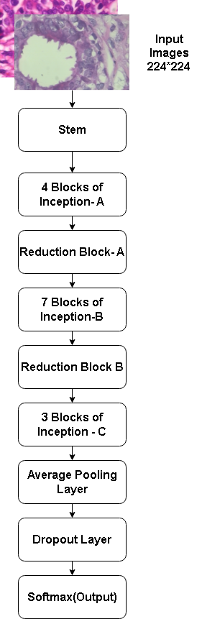

Figure 1: Inception V4 Architecture

### **Residual Network**

ResNet blocks, as illustrated in Figure 2, were introduced to incorporate residual connections, effectively mitigating gradient-related challenges in deep networks and leading to enhanced training efficiency [19].

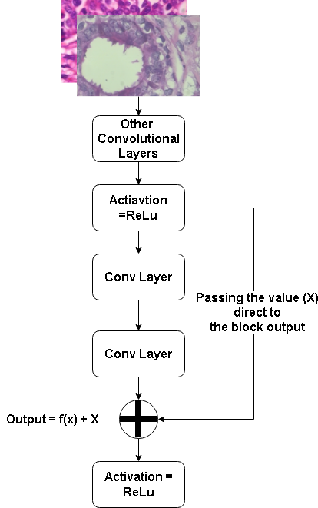

Figure 2: Basic ResNet Block

### **Inception-ResNet Block**

Figure 3 illustrates the fusion of Inception V4 with ResNet Blocks, creating the Inception-ResNet Blocks structure. This hybrid design incorporates the multi-path feature extraction of Inception with the gradient-enhancing properties of ResNet. By combining these elements, Inception-ResNet Blocks enable efficient learning of intricate features, leading to more accurate and effective deep learning models [19]. The diagram visually showcases the amalgamation of these techniques, highlighting their collaborative strength in enhancing the network's capabilities.

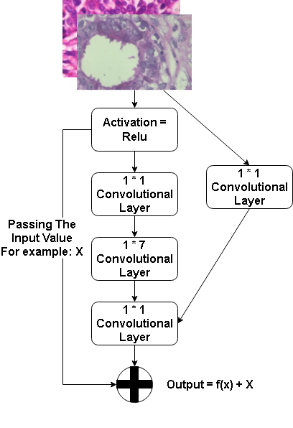 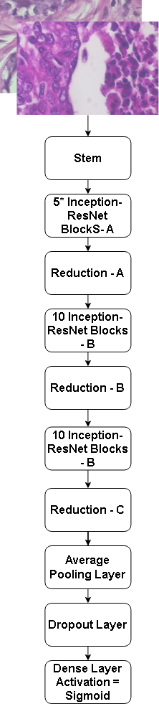

Figure 3: Inception-ResNet Block & Inception-ResNet Architecture

### **Depthwise Convolution Model**

As for depthwise convolution model, it is shown in figure 4 that instead of being an individual model, it is a convolution methodology which reduces the parameters by bypassing unnecessary parameters to deplete the model size and resource being taken [12].

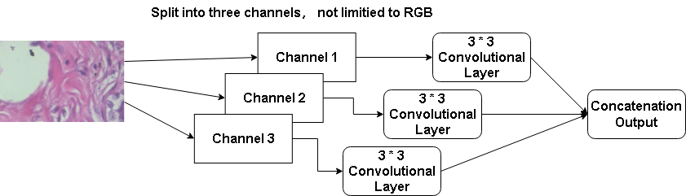

Figure 4: Depthwise Convolution

### **Depthwise-Inception-ResNet Model**

Therefore, Depthwise-Inception-ResNet model is constructed by combining all above which shown in figure 5.

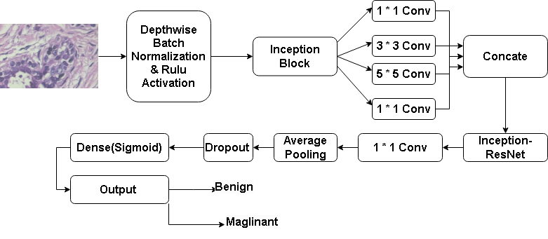

Figure 5: Depthwise-Inception-ResNet Network

Networks with attention mechanisms focus on specific areas for more relevant task-related features [20]. Attention combines a reference with keys to calculate scores, which are then used to determine importance, allowing concentration on specific information. The equations are as follows (equations 1-3).

Attention Score (Q, K) = Q * K^T (*Equation 1*)

Attention Weights (Q, K ) = softmax(Attention Score (Q, K)) (*Equation* 2)

Attention Values (Q, K, V)=Attention Weights(Q, K) * V (*Equation* 3)

The final network will be integrated with attention, therefore, it is shown in figure 6.

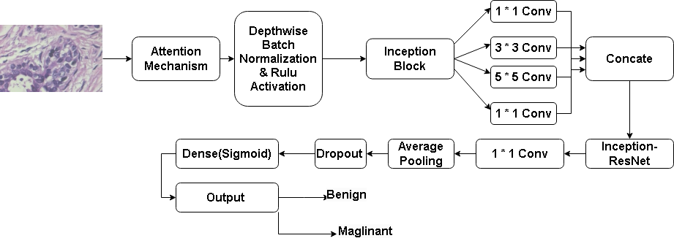

Figure 6: Depthwise-Inception-ResNet-Attention Network

## **3.2 Technology**

The technology this project will be using is displayed in Table 2

|  |  |  |
| --- | --- | --- |
| Software | Framework | Tensorflow |
| Language | Python |
| Libraries | Numpy, Keras, Matplolib |
| Hardware | Central processing unit(CPU) | Intel(R) Core(TM) i7-8750H CPU @ 2.2PGHz(12 CPUs), ~2.2GHz |
| Graphic Processing Unit(GPU) | NVIDIA GeForce GTX 2060 |

Table 2: Summary of Relevant Technology involved in this project

## **3.3 Version management plan**

To manage the different versions of codes modification, I plan to use Github as the version management tools for keeping code updated and secure.

URL is as follow: <https://github.com/Vio1etV/Deep-Learning-Project.git>

# **Project Management**

## **Activities**

|  |  |
| --- | --- |
| Phase | **Objectives** |
| 1. **Preparation** | 1. Review breast cancer deep learning. 2. Identify and narrow issues 3. Seek possible solutions. 4. Study classification methods. |
| 1. **Deep learning knowledge absorbing** | 1. Research breast cancer symptom classification methods 2. Study at least six CNN models and relevant programming libraries. 3. Grasp loss functions, optimizers, model building, and optimization. 4. Investigate extra mechanism for suitability. |
| 1. **Data collection** | 1. Gather 2 - 3 datasets from Kaggle 2. Split them into two classes: benign & malignant 3. Decide the training and test ratio |
| 1. **Development and Implementation** | 1. Build Inception-ResNet model. 2. Add depthwise into Inception-ResNet 3. Train, analyze, and compare models. 4. Optimize the chosen model and adjust hyperparameters if needed. |
| 1. **Testing and Finishing up** | 1. Change other similar datasets to check the generalization capability of the model 2. Analyze the results and summarize the work 3. Write Project Report and Prepare presentation |

## **Schedule**

**The schedule is shown as table 3 below**

**For instance**: 1- 1 means Phase 1, Objective 1

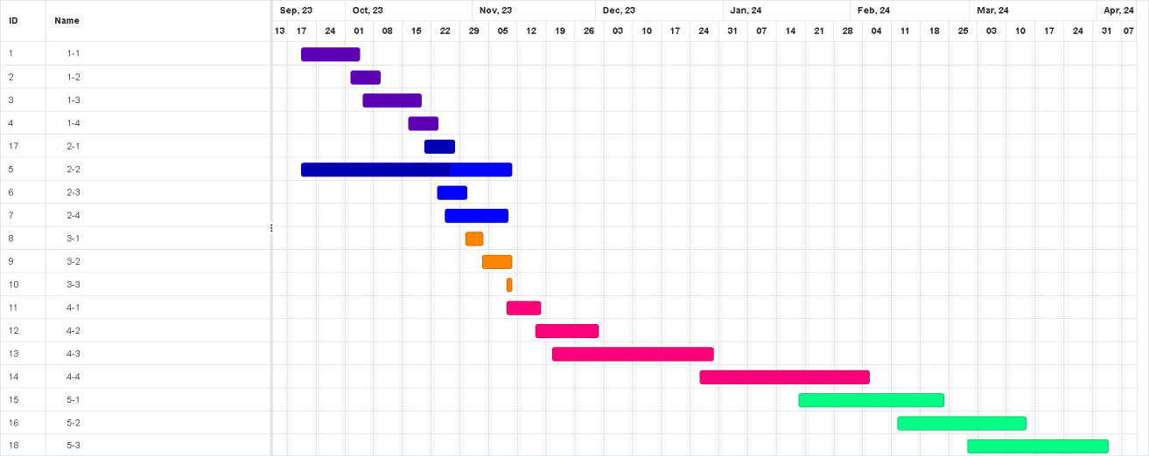

Table 3: Gantt Chart

## **Data management plan**

1. All files including datasets, model codes, references, weekly reports and all sorts will be replicated into three copies for fail safe, one on local computer, one on hard drive, one on github
2. Upload the project to github for every modification, synchronize the project on three platforms

Following are documents of the Project for uploading and synchronization:

1. Reports (Weekly, Proposal, Progress, Final) & Presentation PPT
2. CNN model diagram
3. References
4. Datasets Link
5. Model evaluation documents
6. CNN model codes (Different versions)

## **Deliverables**

1. The project proposal
2. Weekly report
3. Progress Report
4. Final Project Report
5. Project codes
6. Project presentation slides
7. Project presentation

# **5 References**‌‌‌‌‌‌‌‌‌‌‌‌‌‌‌‌‌‌‌‌‌‌‌

[1] I. Hirra et al., "Breast Cancer Classification From Histopathological Images Using Patch-Based Deep Learning Modeling," in IEEE Access, vol. 9, pp. 24273-24287, 2021, doi: 10.1109/ACCESS.2021.3056516.

[2] M. Desai and M. Shah, ‘An anatomization on breast cancer detection and diagnosis employing multi-layer perceptron neural network (MLP) and Convolutional neural network (CNN)’, *Clin. EHealth*, vol. 4, pp. 1–11, Jan. 2021, doi: 10.1016/j.ceh.2020.11.002.

[3] G. Hamed, M. Marey, S. E. Amin and M. F. Tolba, "Automated Breast Cancer Detection and Classification in Full Field Digital Mammograms Using Two Full and Cropped Detection Paths Approach," in IEEE Access, vol. 9, pp. 116898- 116913, 2021, doi: 10.1109/ACCESS.2021.3105924.

[4] F. F. Ting, Y. J. Tan, and K. S. Sim, ‘Convolutional neural network improvement for breast cancer classification’, *Expert Syst. Appl.*, vol. 120, pp. 103–115, Apr. 2019, doi: 10.1016/j.eswa.2018.11.008.

[5] H. Aljuaid, N. Alturki, N. Alsubaie, L. Cavallaro, and A. Liotta, ‘Computer-aided diagnosis for breast cancer classification using deep neural networks and transfer learning’, *Comput. Methods Programs Biomed.*, vol. 223, p. 106951, Aug. 2022, doi: 10.1016/j.cmpb.2022.106951.

[6] A. Sahu, P. K. Das, and S. Meher, ‘An efficient deep learning scheme to detect breast cancer using mammogram and ultrasound breast images’, *Biomed. Signal Process. Control*, vol. 87, p. 105377, Jan. 2024, doi: 10.1016/j.bspc.2023.105377.

[7] H. Lee, J. Park and J. Y. Hwang, "Channel Attention Module With Multiscale Grid Average Pooling for Breast Cancer Segmentation in an Ultrasound Image," in IEEE Transactions on Ultrasonics, Ferroelectrics, and Frequency Control, vol. 67, no. 7, pp. 1344-1353, July 2020, doi: 10.1109/TUFFC.2020.2972573.

[8] H. Wang, X. Shen, K. Fang, Z. Dai, G. Wei, and L.-F. Chen, “Contrast-enhanced magnetic resonance image segmentation based on improved U-Net and Inception-ResNet in the diagnosis of spinal metastases,” *Journal of Bone Oncology*, vol. 42, p. 100498, Oct. 2023, doi: 10.1016/j.jbo.2023.100498.

[9] Y. Liang and Z. Meng, "Brea-Net: An Interpretable Dual-Attention Network for Imbalanced Breast Cancer Classification," in IEEE Access, vol. 11, pp. 100508- 100517, 2023, doi: 10.1109/ACCESS.2023.3314978.

[10] H. Lee, J. Park and J. Y. Hwang, "Channel Attention Module With Multiscale Grid Average Pooling for Breast Cancer Segmentation in an Ultrasound Image," in IEEE Transactions on Ultrasonics, Ferroelectrics, and Frequency Control, vol. 67, no. 7, pp. 1344-1353, July 2020, doi: 10.1109/TUFFC.2020.2972573.

[11] I. U. Haq, H. Ali, H. Y. Wang, C. Lei, and H. Ali, ‘Feature fusion and Ensemble learning-based CNN model for mammographic image classification’, *J. King Saud Univ. - Comput. Inf. Sci.*, vol. 34, no. 6, Part B, pp. 3310–3318, Jun. 2022, doi: 10.1016/j.jksuci.2022.03.023.

[12] E. Alkhaldi and E. Salari, "Ensemble Optimization for Invasive Ductal Carcinoma (IDC) Classification Using Differential Cartesian Genetic Programming," in IEEE Access, vol. 10, pp. 128790-128799, 2022, doi: 10.1109/ACCESS.2022.3228176.

[13] B. Xu et al., "Attention by Selection: A Deep Selective Attention Approach to Breast Cancer Classification," in IEEE Transactions on Medical Imaging, vol. 39, no. 6, pp. 1930-1941, June 2020, doi: 10.1109/TMI.2019.2962013.

[14] N. Wu et al., "Deep Neural Networks Improve Radiologists’ Performance in Breast Cancer Screening," in IEEE Transactions on Medical Imaging, vol. 39, no. 4, pp. 1184-1194, April 2020, doi: 10.1109/TMI.2019.2945514.

[15] H. Chougrad, H. Zouaki, and O. Alheyane, “Deep Convolutional Neural Networks for breast cancer screening,” *Computer Methods and Programs in Biomedicine*, vol. 157, pp. 19–30, Apr. 2018, doi: 10.1016/j.cmpb.2018.01.011.

[16] X. Yu, C. Kang, D. S. Guttery, S. Kadry, Y. Chen and Y. -D. Zhang, "ResNet- SCDA-50 for Breast Abnormality Classification," in IEEE/ACM Transactions on Computational Biology and Bioinformatics, vol. 18, no. 1, pp. 94-102, 1 Jan.-Feb. 2021, doi: 10.1109/TCBB.2020.2986544.

[17] N. Arya and S. Saha, "Multi-Modal Classification for Human Breast Cancer Prognosis Prediction: Proposal of Deep-Learning Based Stacked Ensemble Model," in IEEE/ACM Transactions on Computational Biology and Bioinformatics, vol. 19, no. 2, pp. 1032-1041, 1 March-April 2022, doi: 10.1109/TCBB.2020.3018467.

[18] R. Athilakshmi, R. Jansi and R. Upadhyay, "Enhancing Diabetic Retinopathy Diagnosis with Inception v4: A Deep Learning Approach," 2023 5th International Conference on Inventive Research in Computing Applications (ICIRCA), Coimbatore, India, 2023, pp. 905-910, doi: 10.1109/ICIRCA57980.2023.10220890.

[19] C. Szegedy, S. Ioffe, V. Vanhoucke, and A. Alemi, ‘Inception-v4, Inception- ResNet and the Impact of Residual Connections on Learning’. arXiv, Aug. 23, 2016. doi: 10.48550/arXiv.1602.07261.

[20] Y. Jiang, Z. Huang, L. Li, and Q. Dong, “Local-global dual attention network (LGANet) for population estimation using remote sensing imagery,” *Resources, Environment and Sustainability*, vol. 14, pp. 100136–100136, Dec. 2023, doi: doi: 10.1016/j.resenv.2023.100136.‌